# **D2L (Desire 2 Learn) 3rd Party App**

Class/Section - 4850-02

Fall Semester 2023

Date: 08/31/2023

 Sean Work

 Christopher Dymanus

 Kenneth Molinari

**Software Requirements**  
**Specification**

______________________  
3rd Party Project Planning D2L Application  
Version 1.0 approved  
Prepared by Sean Work, Kenneth Molinari, Christopher Dymanus  
KSU  
08/30/2023

Table of Contents

**D2L 3rd Party App** 1

Revision History 6

1. Introduction 6

1.1 Purpose 6

1.2 Document Conventions 6

1.3 Project Scope 6

1.4 References 7

2. Overall Description 7

2.1 Product Perspective 7

2.2 User Classes and Characteristics 8

2.3 Operating Environment 8

2.4 Design and Implementation Constraints 8

2.5 Assumptions and Dependencies 8

3. System Features 9

3.1 Survey/Questionnaire Creation 9

3.1.1 Description 9

3.2 Project/Team Creation 9

3.2.1 Description 9

3.2.2 Stimulus/Response Sequences 10

3.3 Data Display 10

3.3.1 Description 10

3.3.2 Stimulus/Response Sequences 10

3.4 Deadline Scheduler 10

3.4.1 Description 10

3.4.2 Stimulus/Response Sequences 10

3.5 Login (Tentative) 11

3.4.1 Description 11

3.4.2 Stimulus/Response Sequences 11

3.6 Home Management Page 11

3.6.1 Description 11

3.6.2 Stimulus/Response Sequences 12

4. Data Requirements 13

4.1 Logical Data Model 13

4.2 Data Dictionary 13

4.3 Reports 13

4.4 Data Acquisition, Integrity, Retention, and Disposal 13

5. External Interface Requirements 14

5.1 User Interfaces 14

5.2 Software Interfaces 14

5.4 Communications Interfaces 15

6. Quality Attributes 16

6.1 Usability 16

6.2 Performance 16

6.3 Security 16

7. Internationalization and 17

Localization Requirements 17

8. Other Requirements 18

Appendix A 19

Appendix B 20

# Revision History

|  |  |  |  |
| --- | --- | --- | --- |
| Name | Date | Reason for Change | Version |
|  |  |  |  |
|  |  |  |  |

# 1. Introduction

_______________________________________________________  
The following Software Requirements Specification (SRS) document will elaborate on the detailed guidelines on the development of the 3rd Party Project Planning D2L Application (D2LPP). This document will focus on expanding and understanding the scope, user base and functional requirements. (Tentative due to the dependency of API approval.)

## 1.1 Purpose

The purpose of this SRS document is to outline the software requirements for the 3rd Party Project Planning D2L Application (PPD2L), Version 1.0. It is intended to be to be read and understood by software developers, project managers, QA/Testing teams, Tech writers and ultimately any end user for the product.

## 1.2 Document Conventions

Bold: Indicative of sections/sub-sections.

Font: Arial

Size: For sub-headings and general text font size 12.

For main headings font size 18.

3rd Party Project Planning D2L Application appreciation will be (D2LPP).

## 1.3 Project Scope

This software is seeking to produce an extension to the existing D2L Platform at our educational institution. The core functions of our application will include group project management, creation of customizable surveys, and implementation of automated notifications and deadlines. This extension will streamline faculty administrative tasks and render the existing project coordination processes obsolete.

## 1.4 References

D2L Platform Official Documentation

KSU IT Policies

# 2. Overall Description

_______________________________________________________  
The 3rd Party Project Planning D2L Application (D2LPP) aims to enhance and elaborate on the existing D2L platform by simplifying the current project planning and management process that currently lacks modern ease of use and useful functionality.

## 2.1 Product Perspective

This software is an entirely new product that will function as an extension that can be applied to the current D2L platform. It’s a stand-alone product that will encompass all user requirements and be encapsulated in the D2L 3rd Party Marketplace.

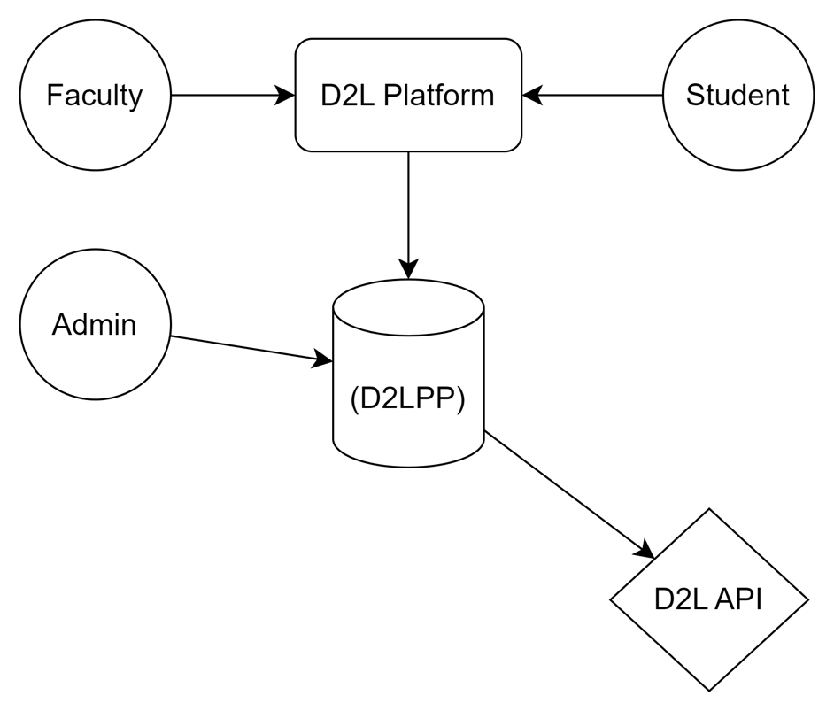

## 2.2 User Classes and Characteristics

Our (D2LPP) application will have a few User classes:

*Faculty*: Primary users interested in simplifying, efficiently creating, and managing projects from beginning to end.

*Students*: Limited interaction, mainly recipients of notifications/surveys and will provide input to aggregate data for Faculty user.

*Admin*: Overseer user(s) that maintain the extension.

## 2.3 Operating Environment

*Hardware*: Any device capable of running and accessing the D2L environment.

*Software*: Shares compatibility with all modern web browsers (Chrome, Firefox, Edge, Safari, Opera, etc.)

*Servers*: Hosted by the institutional servers to comply with any security concerns.

## 2.4 Design and Implementation Constraints

* Must adhere to institutional IT policies.
* Must be compliant with FERPA and any other security regulations/laws.

## 2.5 Assumptions and Dependencies

*Assumptions*

* Faculty and Students already have functioning D2L accounts.
* The application will be downloadable and integrated via the 3rd party D2L marketplace.
* The language chosen for development (Python/JavaScript) will have no issues utilizing the D2L API.

*Dependencies*

* Requires D2L’s existing API for integration with the main software.
* (TBD)

# 3. System Features

_______________________________________________________

The application offers a range of new modern features that are designed to enhance the project management process and information collection for both faculty and students.

## 3.1 Survey/Questionnaire Creation

### 3.1.1 Description

A process that allows for the creation of surveys/questionnaires. It will provide templates to add unique questions from the faculty and will provide aggregated statistics from the collected data. There will be an option to send the completed Survey/Questionnaire to individuals, project teams, or the whole class.  
  
3.1.2 Stimulus/Response Sequences

- Faculty logs into the app and navigates to the "Create Survey" section.

- The app provides a user interface to design the survey.

- Faculty designs the survey and sends it out.

- The app notifies students or teams about the new survey.  
  
3.1.3 Functional Requirements

- Must support various types of questions

- Must provide aggregated statistics for responses.

- Must have the capability to send to selected individuals, project teams, or classes.

## 3.2 Project/Team Creation

### 3.2.1 Description

Will allow to instantiate a class project that pulls all currently available students into a team creation editor. Team creation can either be automatically created with a sent-out survey/questionnaire or manually input via the editor. There will be options and features to name, differentiate and a specific section to create unique deadlines if the current group project doesn’t match up to overall guidelines.

### 3.2.2 Stimulus/Response Sequences

- Faculty logs in and navigates to "Create Project."

- The system provides an editor for team creation.

- Faculty either manually creates teams or allows the system to automatically group students via survey.  
  
3.2.3 Functional Requirements

- Must pull in student data for team creation.

- Must allow both automatic and manual team creation.

- Must support the setting of individual deadlines for different teams.

## 3.3 Data Display

### 3.3.1 Description

Will provide a place to view all the currently received data from currently running projects as well as deadline progress for any currently running groups.

### 3.3.2 Stimulus/Response Sequences

- Faculty logs in and goes to "Data Display."

- The system shows metrics related to ongoing projects and deadlines.  
  
 3.3.3 Functional Requirements

- Must display data related to ongoing projects.

- Must show deadline progress for each team.

## 3.4 Deadline Scheduler

### 3.4.1 Description

An overarching scheduler that will allow for specific dates to be applied to a group of currently running Project Teams that will be applied to their view.

### 3.4.2 Stimulus/Response Sequences

- Faculty logs in and navigates to "Deadline Scheduler."

- The system allows for the setting or modification of project deadlines.   
  
 3.4.3 Functional Requirements

- Must allow for the setting and modification of deadlines for individual projects.

## 3.5 Login (Tentative)

### 3.4.1 Description

A login that will differentiate between student, teacher and admin. Will provide an option to reset password via email. The entry point of the application.

### 3.4.2 Stimulus/Response Sequences

- Student logs into their account and can reset their password if necessary.

- Faculty logs into their account and can reset their password if necessary.  
  
 3.4.3 Functional Requirements

- NA

## 3.6 Home Management Page

### 3.6.1 Description

Depending on the user the Home Management page will either display the current multiple running projects of the classroom or will show the current project the student user is connected with. For the Faculty User, we will see a list of currently ongoing projects with visual progress bars according to their deadlines and an ability to select and edit the teams inside, the tool bar on the top (or left) will provide buttons with drop downs to Create, Schedule, Data, and Notify. For the Student User they will be able to see their deadline progress bar with the ability to update it, project name and information, and lastly a section to view any current notifications from the Faculty User

### 3.6.2 Stimulus/Response Sequences

- User logs in.

- The system displays relevant projects or deadlines based on the user role.   
  
  
 3.6.3 Functional Requirements

- Must show different information based on user roles.

- For Faculty: Must show list of current projects and their deadlines.

- For Students: Must show current project and deadline.

# 4. Data Requirements

_______________________________________________________

## 4.1 Logical Data Model

This section will focus on illustrating the relationships between the entities in our software. Need a literal model

## 4.2 Data Dictionary

This is tentative and may be expanded upon in the future.

* *Faculty_ID*: Unique identifier (integer)
* *Student_ID*: Unique identifier (integer)
* *Project_Name:* Text Description (string)
* *Team_Name*: Text Description (string)
* *Deadline_Date*: Date for project deadline(s) (datetime)
* *Survey_Questions*: Questions for surveys (string)
* *Dropdown_Elements*: Text description for question choices (string, int, float, booklet)

## 4.3 Reports

Our software will produce multiple types of reports to aid in project management.

**Project Status Reports**: These will provide insight into ongoing projects and their current deadline status.

**Survey Summary Results**: Aggregated data on survey responses that can be viewed all together or separately by student/group.

**Team Progress Reports**: (***Tentative***) Visual Timelines or Gantt charts representing current class/group progress.

## 4.4 Data Acquisition, Integrity, Retention, and Disposal

Since this is an extension of the D2L/institutional systems any data collected will follow any existing policies that come from the existing systems. All data will be stored by the institution utilizing the software.

# 5. External Interface Requirements

_______________________________________________________

## 5.1 User Interfaces

**- Home Screen**

A login and password input fields with a "Forgot Password?" Link.

**(For Students)** Includes a progress meter, progress status checklist, and a notification icon at the top right corner.

**(For Teachers)** TBD

- **Student Section Menu** options available include:

*Meet with Teacher*: Allows scheduling of a meeting with the teacher.

*Peer Review*: Enables the review of peer-submitted projects.

*Check-in Code*: A feature to enter a code displayed by the teacher as an attendance verification method.

*Logout*: Logs out the user from the application.

- **Teacher Section menu** includes:

*Create a Course*: Allows the creation of a new course.

*Select from Active Courses*: Enables the selection from currently active courses.

*Create Project Sign-up*: Facilitates the creation of new project sign-up sheets.

*Scheduler*: To schedule meetings/deadlines.

*Contact Project Owners*: For direct communication via email or notifications.

*View Survey Results*: Allows viewing of ongoing or completed surveys.

*Create/Edit Results*: Editing or creating new results for projects or surveys.

*Create/Edit Teams*: Allows the formation or editing of student teams.

*User Access*: Manages user accessibility settings.

*Admin Privilege*: Special administrative functionalities.

*View Closed Projects*: For reviewing past or closed projects.

*Project Blogs*: A space for free-form writing or updates related to ongoing projects.

*Logout*: Logs out the user from the application.

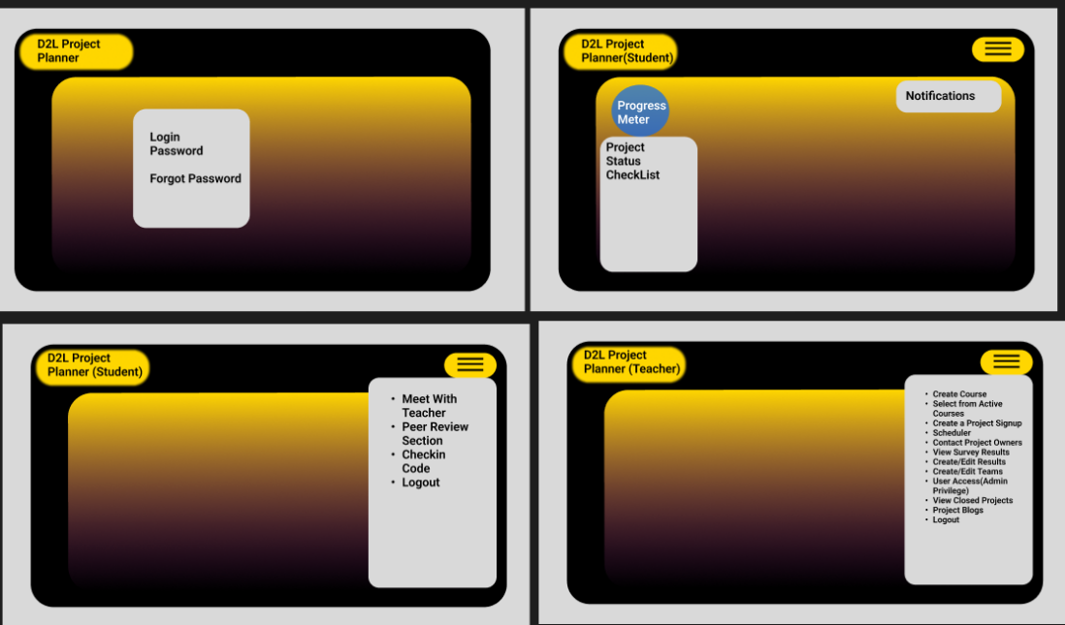

## 5.2 Software Interfaces

- **Microsoft Visual Studio 2022**: This IDE will be used for developing the front and back-end of the web application. This will be tightly coupled with the .NET 7 Framework.

*Purpose*: Code Development and Debugging

- **Microsoft SQL Management Studio(Latest)**:Will be used as database management tool.

*Purpose*: Database Schema Design and Data management

- **Azure Web Services**:Used to host the web application as well as the project repository.

*Purpose*: Web Hosting, CI/CD, Repository Management

- **.NET 7 Framework**:Will be used for server-side logic.

*Purpose*: Web Application development

5.3 Communications Interfaces

- **Email**:SMTP Protocol for notifications and alerts.

*Security*: SSL/TLS encryption

- **Web Browser**:HTTP/HTTPS for web application access.

*Security*: SSL for HTTPS

- **Database Connections**:Connection strings via .NET to SQL Server.

*Security*: Restricted IP access and String encryption

- **Azure/GitHub Repository**:Git Protocol for Version Control.

*Security*: Two-Factor Authentication

- **Survey/Forms**:Built in forms.

*Security*: SSL encryption

6. Quality Attributes

_______________________________________________________

## 6.1 Usability

The (D2LPP) web application will be providing a simple UI for Students that will prioritize “minimal clicks” to navigate and a much more verbose menu section for creation, editing and deletion for Faculty/Admin. Tentative decision in limbo to make the menu a quick snap to a long page or have multiple pages we will transition too. The data collected will be archived and modifiable even after current projects are closed to allow full access regardless of the setting.

## 6.2 Performance

There are no expectations for the performance of the web application since its very lightweight and not too complex. Depending on the number of users we might have to scale our data storage, but as this is a prototype it is negligible.

## 6.3 Security

As this would be a web application that is integrated into the D2L platform we don’t expect our security to be an issue as this will function inside the already secure ecosystem of the institution. We will however make our prototype demand a login that authenticates properly since we are unable to access the API as of this moment 09/15.

# 7. Internationalization and

# Localization Requirements

_______________________________________________________

Not applicable currently as there should be no localization issues yet since we are primarily focused on D2L United States. If that changes this section will be updated.

# 8. Other Requirements

_______________________________________________________  
Not Applicable as the previous sections tend to contain the full scope of requirements at this moment.

# Appendix A

D2LPP – Desire 2 Learn Project Planning